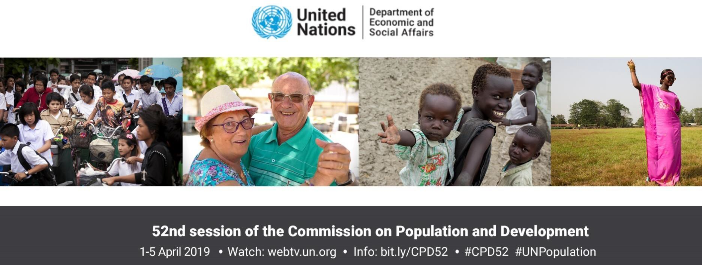Within little more than a decade there are likely to be around 8.5 billion people on earth, and almost 10 billion by 2050, compared to 7.7 billion today. A small number of countries will account for most of the increase. While some countries continue to grow rapidly, others are seeing their populations decline. At the same time, the world is growing older, as global life expectancy continues to rise and the fertility level continues to fall. Such changes in the size and distribution of the world’s population have important consequences for achieving the Sustainable Development Goals (SDGs) and ensuring that no one is left behind.
The world’s population is growing larger and older, while also becoming more mobile and more urbanized. Population size, structure and distribution have major implications for, and will be significantly influenced by, the implementation of the 2030 Agenda for Sustainable Development. The following key findings are based on a report of the Secretary-General which reviews the implementation of the goals and objectives of the Programme of Action of the International Conference on Population and Development (ICPD), adopted in Cairo in 1994.

Key findings

1. Important gains have been made in implementing the Programme of Action
The world has witnessed significant progress in implementing the ICPD Programme of Action, adopted 25 years ago. Examples include greater access to sexual and reproductive health care, reduced child and maternal mortality, increased life expectancy, reduced incidence of poverty, improved access to education and advances in gender equality and the empowerment of women.

2. Nevertheless, progress has been uneven, and some major gaps remain
While the global life expectancy at birth rose from 65 years in 1994 to 72 years in 2019, only half of all countries have achieved the targets included in the Programme of Action. Child mortality levels in sub-Saharan Africa, which fell from 180 to 78 deaths per 1,000 births, remain well above the ICPD target. Likewise, the global maternal mortality ratio, despite significant gains, is still above the target established in 1994.
3. World’s population is expected to continue to grow, albeit at a declining rate
The annual rate of population growth fell from1.4 per cent in 1994 to 1.1 per cent today. This growth is projected to slow further in the coming decades. Meeting the demand for resources from a growing and more prosperous population, while protecting the environment and combating climate change, remains a central challenge for achieving sustainable development.
4. Global fertility is projected to reach a level around 2.1 births per woman by the 2060s Between 1994 and 2019, the total fertility rate fell from 2.9 to 2.5 births per woman. Today, over half of the world’s population lives in countries with fertility under 2.1 births per woman,

continues

World Population Prospects 2019: Highlights
June 2019 . https://population.un.org/wpp/ . #UNPopulation . #WPP2019
The following key findings are based on World Population Prospects 2019: Highlights, which presents the latest round of global population estimates and projections by the United Nations.
Ten key findings
- The world’s population continues to increase, but growth rates vary greatly across regions
The world’s population is projected to grow from 7.7 billion in 2019 to 8.5 billion in 2030 (10% increase), and further to 9.7 billion in 2050 (26%) and to 10.9 billion in 2100 (42%). The population of sub-Saharan Africa is projected to double by 2050 (99%). Other regions will see varying rates of increase between 2019 and 2050: Oceania excluding Australia/New Zealand (56%), Northern Africa and Western Asia (46%), Australia/New Zealand (28%), Central and Southern Asia (25%), Eastern and South-Eastern Asia (3%), and Europe and Northern America (2%).
- Nine countries will make up more than half the projected population growth between now and 2050
The largest increases in population between 2019 and 2050 will take place in: India, Nigeria, Pakistan, the Demographic Republic of the Congo, Ethiopia, the United Republic of Tanzania, Indonesia, Egypt and the United States of America (in descending order of the expected increase). Around 2027, India is projected to overtake China as the world’s most populous country.
- Rapid population growth presents challenges for sustainable development
Many of the fastest growing populations are in the poorest countries, where population growth brings additional challenges in the effort to eradicate poverty (SDG 1), achieve greater equality (SDGs 5 and 10), combat hunger and malnutrition (SDG 2), and strengthen the coverage and quality of health and education systems (SDGs 3 and 4).
- In some countries, growth of the working-age population is creating opportunities for economic growth
In most of sub-Saharan Africa, and in parts of Asia, Latin America and the Caribbean, recent reductions in fertility have caused the population at working ages (25-64 years) to grow faster than at other ages, creating an opportunity for accelerated economic growth. To benefit from this “demographic dividend”, governments should invest in education and health, especially for young people, and create conditions conducive to sustained economic growth.
continues

- Globally, women are having fewer babies, but fertility rates remain high in some parts of the world
Today, close to half of all people globally live in a country or area where fertility is below 2.1 births per woman over a lifetime. In 2019, fertility remains above this level, on average, in sub-Saharan Africa (4.6), Oceania excluding Australia/New Zealand (3.4), Northern Africa and Western Asia (2.9), and Central and Southern Asia (2.4). The global fertility rate, which fell from 3.2 births per woman in 1990 to 2.5 in 2019, is projected to decline further to 2.2 in 2050.
- People are living longer, but those in the poorest countries still live 7 years less than the global average
Life expectancy at birth for the world, which increased from 64.2 years in 1990 to 72.6 years in 2019, is expected to increase further to 77.1 years in 2050. While considerable progress has been made in closing the longevity differential between countries, large gaps remain. In 2019, life expectancy at birth in the least developed countries lags 7.4 years behind the global average, due largely to persistently high child and maternal mortality rates, as well as violence, conflict and the continuing impact of the HIV epidemic.
- The world’s population is growing older, with persons over age 65 being the fastest growing age group
By 2050, one in six people in the world will be over age 65 (16%), up from one in 11 in 2019 (9%). Regions where the share of the population aged 65 years or over is projected to double between 2019 and 2050 include Northern Africa and Western Asia, Central and Southern Asia, Eastern and South-Eastern Asia, and Latin America and the Caribbean. By 2050, one in four persons living in Europe and Northern America could be aged 65 or over. In 2018, for the first time in history, persons aged 65 or above outnumbered children under five years of age. The number of persons aged 80 years or over is projected to triple, from 143 million in 2019 to 426 million in 2050.
- Falling proportions of working-age people are putting pressure on social protection systems
The potential support ratio, which compares numbers of working-age people aged 25-64 to those over age 65, is falling around the world. In Japan, this ratio is 1.8, the lowest in the world. An additional 29 countries, mostly in Europe and the Caribbean, already have potential support ratios below three. By 2050, 48 countries, mostly in Europe, Northern America, and Eastern and South-Eastern Asia, are expected to have potential support ratios below two. These low values underscore the potential impact of population ageing on the labour market and economic performance as well as the fiscal pressures that many countries will face in the coming decades as they seek to build and maintain public systems of health care, pensions and social protection for older persons.
- A growing number of countries are experiencing a reduction in population size
Since 2010, 27 countries or areas have experienced a reduction in the size of their populations of one per cent or more. This is caused by low levels of fertility and, in some places, high rates of emigration. Between 2019 and 2050, populations are projected to decrease by one per cent or more in 55 countries or areas, of which 26 may see a reduction of at least ten per cent. In China, for example, the population is projected to decrease by 31.4 million, or 2.2 per cent, between 2019 and 2050.
- Migration has become a major component of population change in some countries
Between 2010 and 2020, Europe and Northern America, Northern Africa and Western Asia, and Australia/ New Zealand will be net receivers of international migrants, while other regions will be net senders. Fourteen countries or areas will see a net inflow of more than one million migrants, while ten countries will see a net outflow of more than one million migrants. Some of the largest migratory movements are driven by the demand for migrant workers (Bangladesh, Nepal and the Philippines) or by violence and armed conflict (Syria, Venezuela and Myanmar). Belarus, Estonia, Germany, Hungary, Italy, Japan, the Russian Federation, Serbia and Ukraine will experience a net inflow of migrants over the decade, helping to offset population losses caused by an excess of deaths over births.
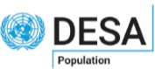
Prepared by the Population Division of the United Nations Department of Economic and Social Affairs, these key findings are based on World Population Prospects 2019: Highlights, a report presenting the main results of the 26th round of official global population estimates and projections by the United Nations. More work of the Population Division is available at www.unpopulation.org.
United Nations | Department of Economic and Social Affairs | Population Division

